

PROJECT REPORT

My Library

Semester Project Report by

Names Zeeshan Hassan Asfandyar khan Abdul Ghaffar
Abdul Basit

(Reg no.) 37723
37243
37698

Iqra University H-9 Campus Islamabad, Pakistan
(2025)

2. Introduction
Project Overview:
The Lumina Library Management System is a dynamic web application that automates library management processes. The system allows administrators to manage books efficiently, track their availability, borrow and reservation status, and maintain real-time records.
Problem Statement:
Traditional manual library management systems are slow, error-prone, and require considerable effort to maintain accurate records. Administrators face challenges in tracking borrowed, reserved, and available books, leading to inefficiencies.
Objectives:
- Develop a dynamic PHP web application with full CRUD functionality.
- Implement a MySQL database for data storage and management.
- Provide a responsive and user-friendly interface using Bootstrap.
- Create a real-time dashboard for monitoring library statistics.
- Deploy the application online for accessibility.

3. Technology Stack
Component | Technology
Backend | PHP
Database | MySQL
Frontend | HTML, CSS, Bootstrap, Font Awesome
Hosting | [Hosting platform, e.g., 000webhost, Hostinger]

4. System Features
Key Functionalities:

CRUD Operations
- Create: Admin can add new books with details like title, author, category, ISBN, and status.
- Read: Admin can view all books in a tabular format with filter options.
- Update: Admin can edit book details including changing status (Available/Borrowed/Reserved).
- Delete: Admin can remove books permanently from the system with confirmation prompt.

Dashboard Features
- Displays total books, available books, borrowed books, and reserved books in stat cards.
- Clicking on a stat card filters the books table by that status.
- Quick action buttons for adding new books and viewing all books.

User Roles
- Admin: Full access to all CRUD operations and dashboard features.

5. Database Design
ER Diagram:
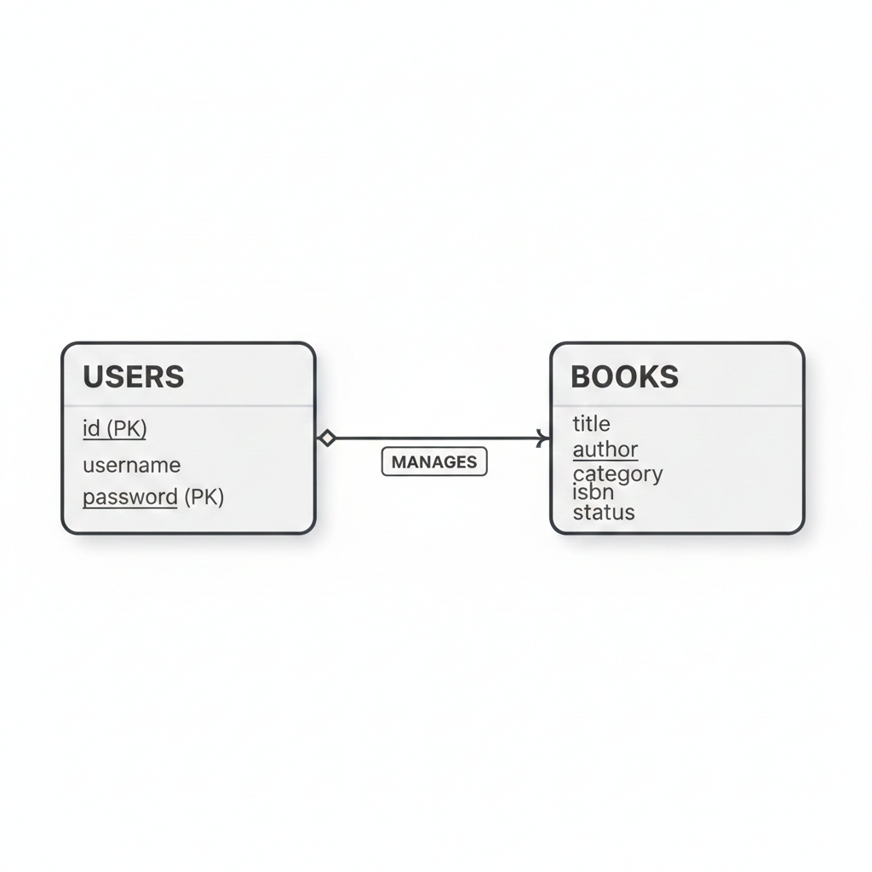

Tables Description:
Table Name | Fields | Description
books | id (PK), title, author, category, isbn, status | Stores all book records with availability and status.
users | id (PK), username, password | Stores admin login credentials (optional if authentication is implemented).
Database Relationships:
- Each book record is independent; status determines availability.
- Users (admins) manage the book records.

6. System Implementation
Architecture:
The system follows a PHP-MySQL architecture with a modular design:
- Database Connection:
  - config/db.php handles connection to MySQL using mysqli.
- CRUD Operations Flow:
Add Book (add_book.php):
- Admin fills in a form with book details.
- Data is validated and inserted into books table.
- After submission, admin is redirected to books.php.
View Books (books.php):
- Displays all books in a table.
- Optionally filters books by status (Available/Borrowed/Reserved) when selected from dashboard.
- Edit/Delete actions available for each book.
Edit Book (edit_book.php):
- Admin clicks "Edit" on a book record.
- A form pre-populated with existing book data appears.
- Updates are saved to the database upon submission.
Delete Book (delete_book.php):
- Admin clicks "Delete" on a book record.
- A confirmation prompt appears to prevent accidental deletion.
- Record is removed from the database if confirmed.
Dashboard (dashboard.php):
- Displays statistics in cards: Total Books, Available, Borrowed, Reserved.
- Cards are clickable to filter books based on status.
- Quick actions for adding/viewing books.
Security Measures:
- Basic session-based authentication ensures only logged-in admins can access the system.
- Input validation prevents empty book records.
- Confirmation prompt prevents accidental deletion.

7. Screenshots
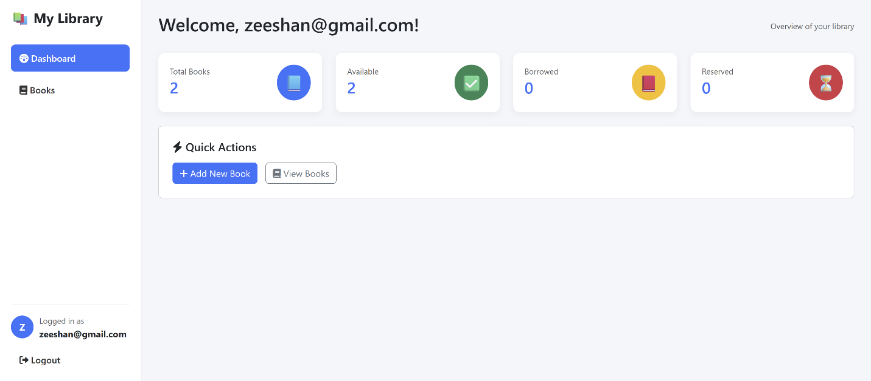
Dashboard

Add Book Form
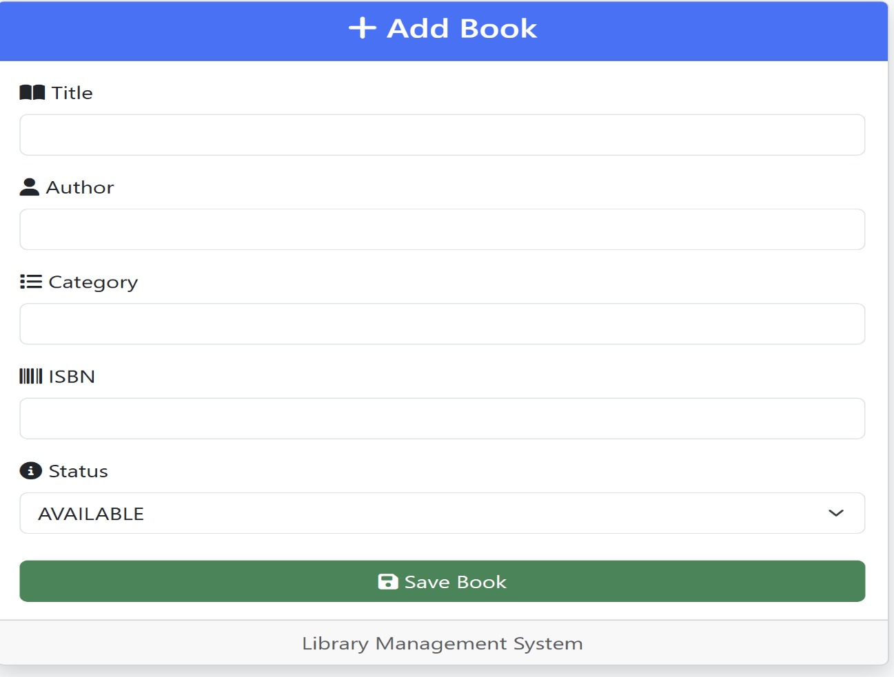
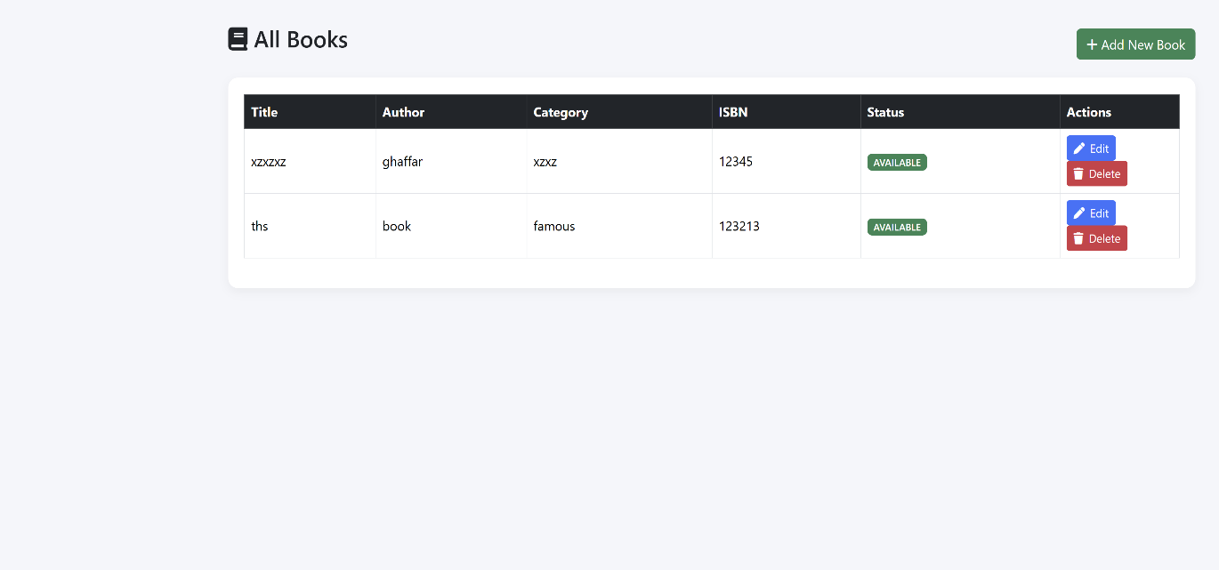
- Books Table

- Edit Book Form
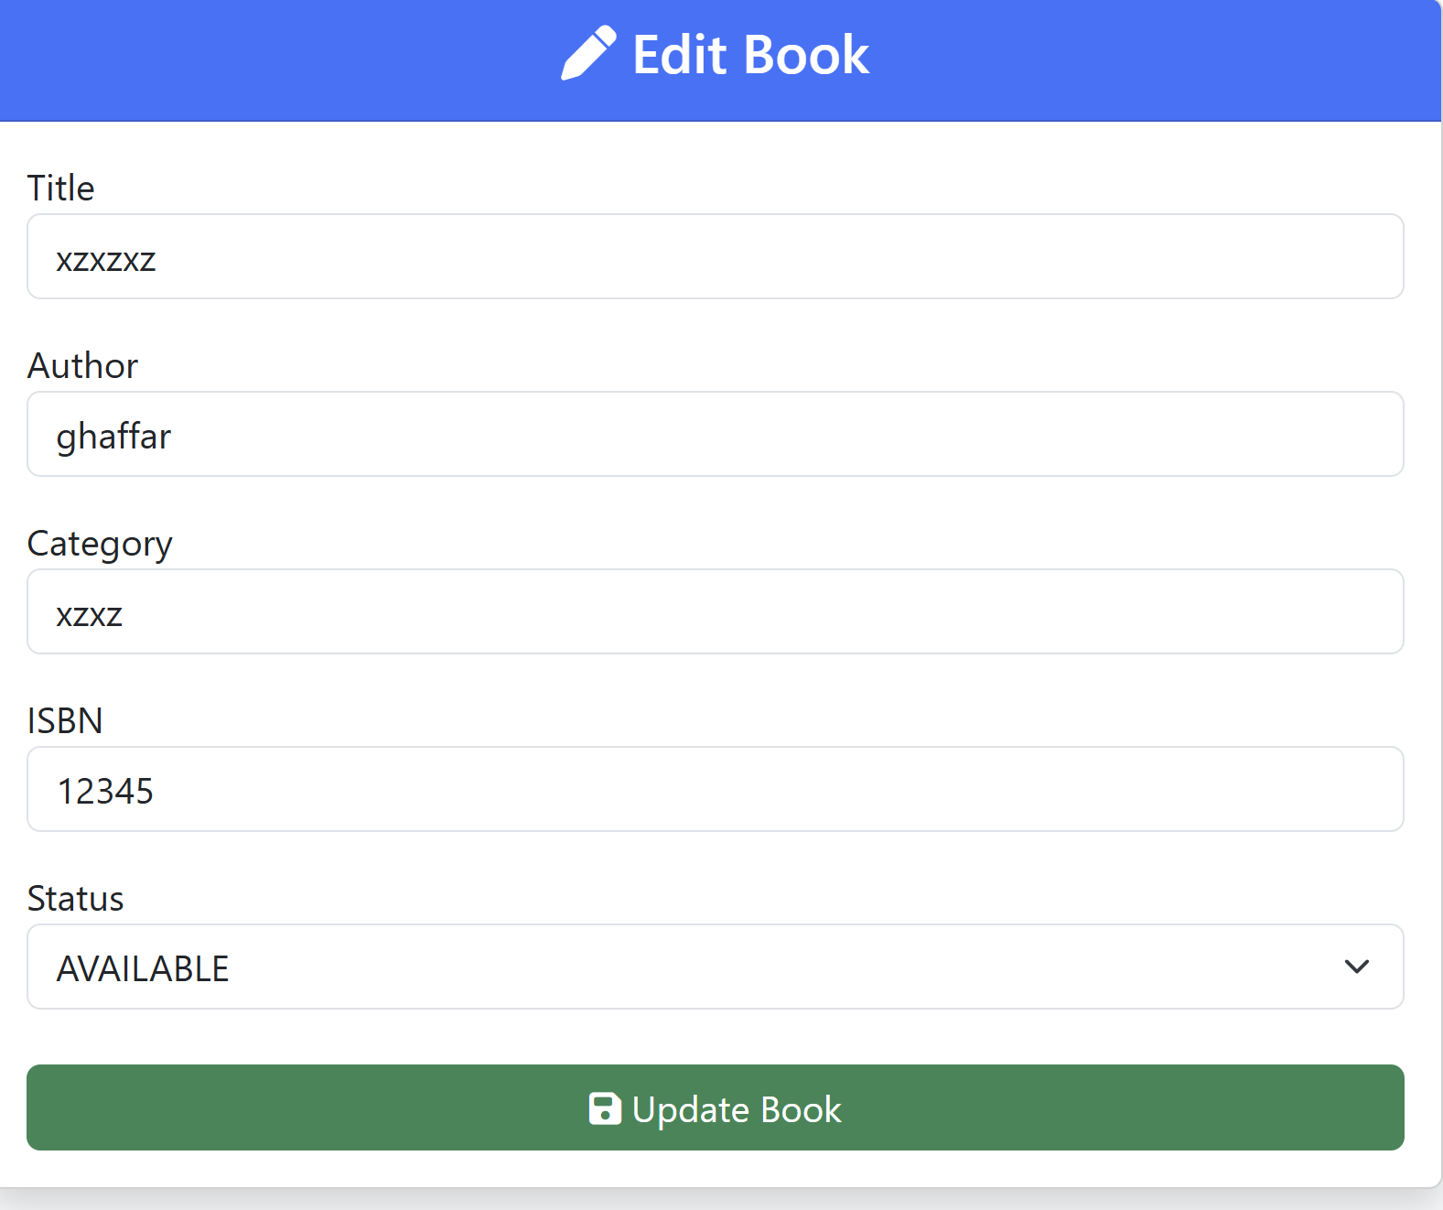
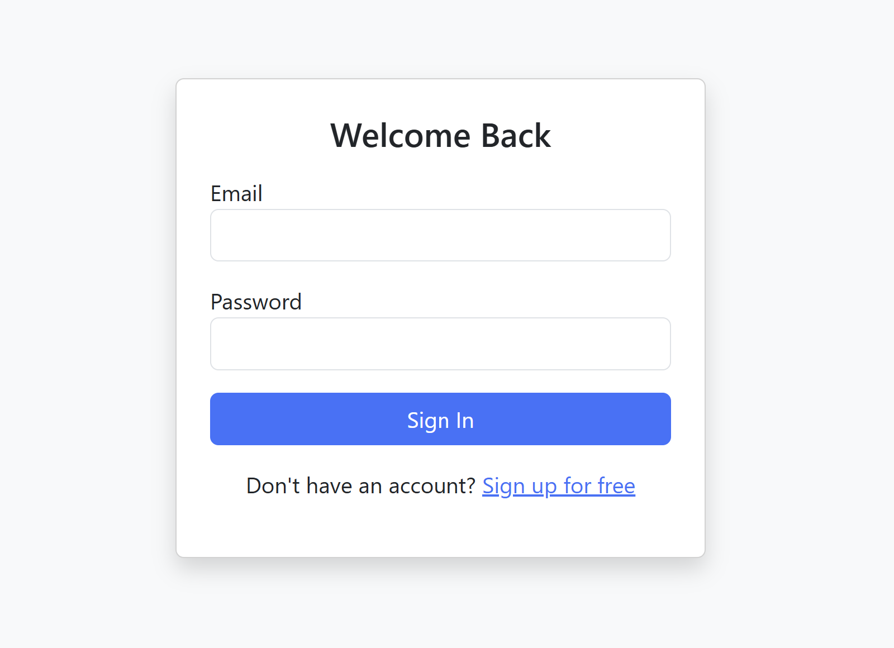
- Login screen

8. Conclusion
Learning Outcomes:
- Gained hands-on experience in PHP & MySQL full-stack web development.
- Learned to implement dynamic CRUD functionality for real-world applications.
- Improved understanding of database design and management.
- Developed UI/UX skills with Bootstrap and Font Awesome.
- Experienced teamwork and project collaboration for a live web application.
Challenges Faced:
- Designing a responsive, user-friendly interface for dashboard and forms.
- Implementing dynamic filtering of books by status.
- Maintaining data integrity and error handling for CRUD operations.
- Deploying the application on a live server with correct database configuration.

